Please click on the file to open.



Figure 1Anupam R assignment 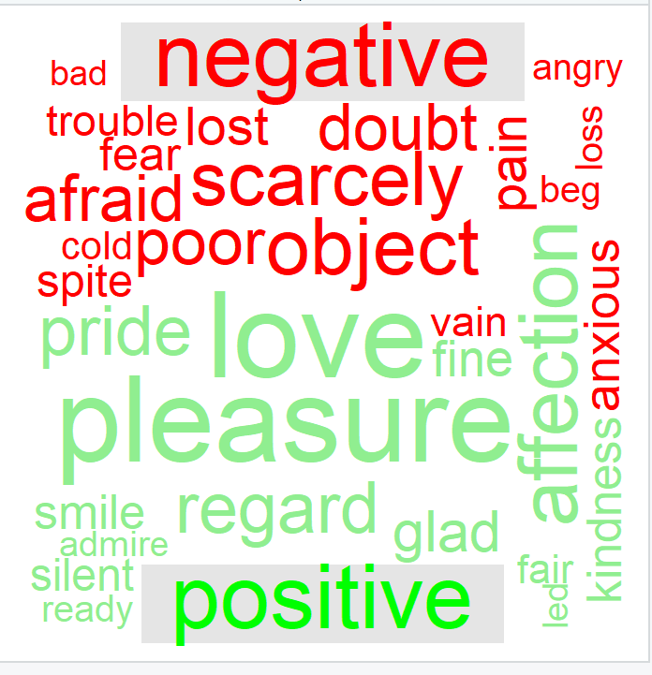

Code:

#library required for data cleaning and wordcloud plotting

library(tidytext)

library(dplyr)

library(reshape2)

library(janeaustenr)

library(ggplot2)

library(wordcloud)

#janeausten books grouped by book name

austen_dataframe <- austen_books() %>%

group_by(book) %>%

mutate(linenumber = row_number())

#filtering Pride & Prejudice book data from austen book dataframe

Pride_dataframe <- austen_dataframe %>% filter(book=="Pride & Prejudice")

#splitting text of book to token words.

tidy_books <- Pride_dataframe %>% unnest_tokens(word, text)

#Removing stopwords

#-----------------------------#

custom_stop_words <- tribble(

# Column names should match stop_words

~word, ~lexicon,

# Addmiss as custom stop words

"miss", "CUSTOM"

)

# Bind the custom stop words to stop_words

stop_words2 <- stop_words %>%

bind_rows(custom_stop_words)

#-----------------------------#

data("stop_words")

tidy_books <- tidy_books %>%

anti_join(stop_words2)

#we used "bing" dictionary for getting positive and negative sentiments

tidy_books %>%

inner_join(get_sentiments("bing")) %>%

count(word, sentiment, sort = TRUE) %>%

acast(word ~ sentiment, value.var = "n", fill = 0) %>%

comparison.cloud(title.colors=c("red","green"),colors = c("red", "lightgreen"),

max.words = 100)